《数据结构》实验报告（三）

学生姓名 李蔚
班 级 计算机2002
学 号 202801108
指导老师 陈 宏 建
成 绩

序号 | 项目名称 | 考核比重 | 得分
1 | 实验预习 | 10%
2 | 实验验收 | 60%
3 | 实验报告 | 30%

2021年 11月 10 日
实验名称： 队列的应用
实验时间： 2021 年 10 月 27 日 第 7 周 星期 三
一、实验预习
1、实验目的
理解并掌握顺序队和链队列的基本操作及算法。
2、实验内容（包括自己设计增加的内容等）
利用顺序队列和链队列分别实现银行叫号器的模拟
二、实验报告
1、实验结果（包括程序运行结果、实测数据结果、数据分析等）
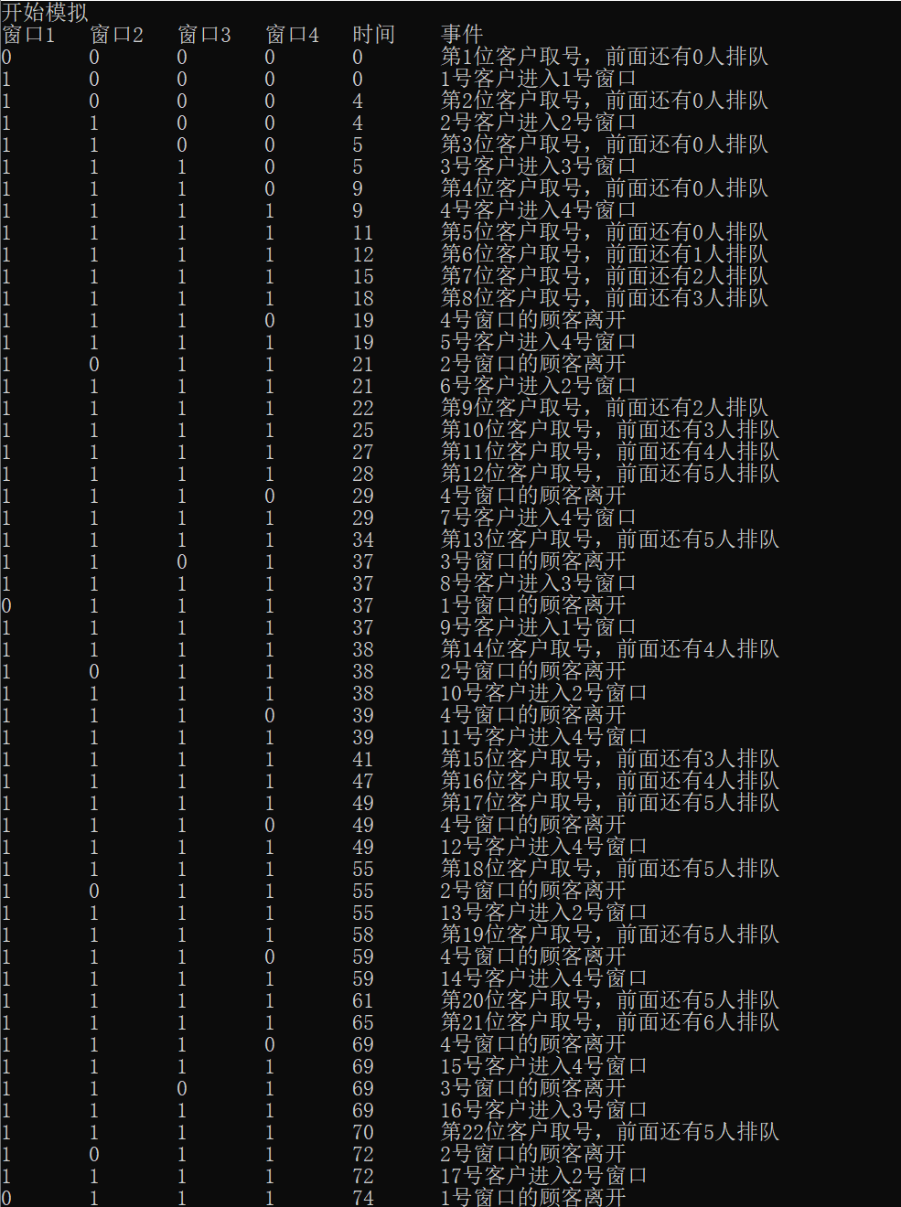
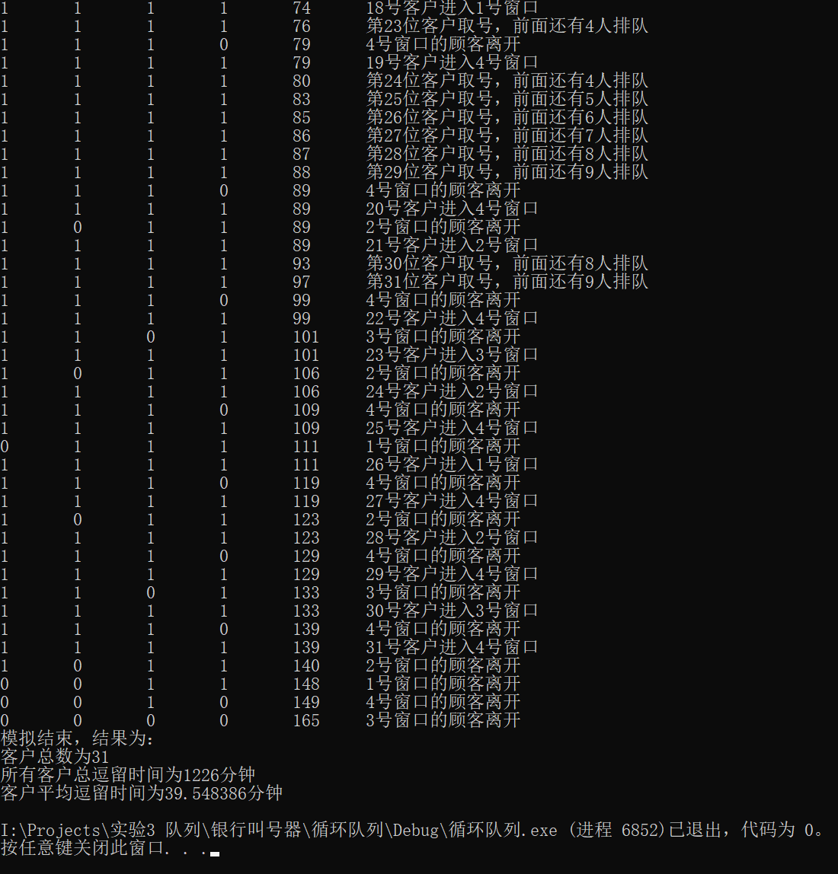
2、实验结论
验证了队列的创建，入队，出队等操作。
学会循环队列和链队列两种队列的表示方法。

附录：（程序源代码）

//循环队列
Main.c
#define _CRT_SECURE_NO_WARNINGS
#include<stdio.h>
#include<stdlib.h>
#include<time.h>
#include"queue.h"
#include"linkedlist.h"
#define CLOSETIME 100//停止取号时间（分钟）
#define WINDOWS 4//服务窗口数
#define MAX_INTERTIME 6//两客户到达时间间隔的最大值
#define MAX_DURTIME 40//单个客户服务时长的最大值
int mini(queue* s[]);
void openforday();
void arrived();
void departure();
void closeforday();
int totaltime = 0;//客户总逗留时间
int customernum = 0;//客户总数
int durtime;//客户办理业务的时间
int intertime;//客户到达的时间间隔
eventlist* ev;
queue * windows[WINDOWS];
queue* waiting;
int main() {
openforday();
while (lengthoflist(ev)) {
event x = ev->next->data;
if (x.eventtype == -1) arrived();
else departure();
eventdelete(ev, ev->next);
}
closeforday();
return 0;
}
int mini(queue* s[]) {
int x = 0;
while (x <= WINDOWS - 1 && lengthofqueue(s[x]) == 1)x++;
return x;
}
void openforday() {
for (int i = 0; i <= WINDOWS - 1; i++) {
windows[i] = queueinit();
}
waiting = queueinit();
ev = listinit();
event i = { 0,-1 };
eventinsert(ev, &i);
srand((unsigned)time(NULL));
printf("开始模拟\n");
for(int i=0;i<=WINDOWS-1;i++)printf("窗口%d\t",i+1);
printf("时间\t事件\n");
}
void arrived() {
customernum++;
durtime = rand() % MAX_DURTIME + 1;
intertime = rand() % MAX_INTERTIME + 1;
event x = { ev->next->data.occurtime + intertime,-1 };
if (x.occurtime < CLOSETIME)orderinsert(ev, &x);
for (int i = 0; i <= WINDOWS - 1; i++)printf("%d\t", lengthofqueue(windows[i]));
printf("%d\t第%d位客户取号，前面还有%d人排队\n", ev->next->data.occurtime, customernum, lengthofqueue(waiting));
int i = mini(&windows[0]);
if (i <= WINDOWS - 1) {
customer a = { ev->next->data.occurtime,durtime };
add(windows[i], &a);
event x = { ev->next->data.occurtime + durtime,i };
orderinsert(ev, &x);
for (int i = 0; i <= WINDOWS - 1; i++)printf("%d\t", lengthofqueue(windows[i]));
printf("%d\t%d号客户进入%d号窗口\n", ev->next->data.occurtime, customernum - lengthofqueue(waiting), i + 1);
}
else {
customer a = { ev->next->data.occurtime,durtime };
add(waiting, &a);
}
}
void departure() {
customer x = *delete(windows[ev->next->data.eventtype]);
totaltime += ev->next->data.occurtime - x.arrivetime;
for (int i = 0; i <= WINDOWS - 1; i++)printf("%d\t", lengthofqueue(windows[i]));
printf("%d\t%d号窗口的顾客离开\n", ev->next->data.occurtime, ev->next->data.eventtype + 1);
if (!isempty(waiting)) {
add(windows[ev->next->data.eventtype], delete(waiting));
event x = { ev->next->data.occurtime + windows[ev->next->data.eventtype]->data[1].durtime,ev->next->data.eventtype };
orderinsert(ev, &x);
for (int i = 0; i <= WINDOWS - 1; i++)printf("%d\t", lengthofqueue(windows[i]));
printf("%d\t%d号客户进入%d号窗口\n", ev->next->data.occurtime, customernum - lengthofqueue(waiting), ev->next->data.eventtype + 1);
}
}
void closeforday() {
printf("模拟结束，结果为：\n");
printf("客户总数为%d\n所有客户总逗留时间为%d分钟\n", customernum, totaltime);
printf("客户平均逗留时间为%f分钟\n", (float)totaltime / customernum);
}
Linkedlist.h
#pragma once
typedef struct {
int occurtime;
int eventtype;
}event;
typedef struct eventlist {
event data;
struct eventlist* next;
}eventlist;
eventlist* listinit() {//创建空表
eventlist* L;
L = (eventlist*)malloc(sizeof(eventlist));
L->next = NULL;
return L;
}
int lengthoflist(eventlist* H) {//求表长
eventlist* p = H->next;
int i = 0;
while (p != NULL) {
p = p->next;
i++;
}
return i;
}
void printlist(eventlist* H) {//遍历输出
eventlist* p = H->next;
while (p!=NULL) {
printf("%d\t%d\n", p->data.occurtime, p->data.eventtype);
p = p->next;
}
}
eventlist* listlocate(eventlist* H, event* x) {//按值查找
eventlist* p = H->next;
while (p!=NULL&& p->data.occurtime!= x->occurtime)p = p->next;
if (p!=NULL)return p;
else return NULL;
}
eventlist* pre(eventlist* H, eventlist*L) {//查找前驱
if (L==H||L==NULL)return NULL;
else {
eventlist* pre = H;
while (pre->next != L&&pre!=NULL)pre = pre->next;
if(pre!=NULL)return pre;
else return NULL;
}
}
void eventinsert(eventlist* L,event*x ) {//在给定结点后插入结点
eventlist* new;
new = (eventlist*)malloc(sizeof(eventlist));
new->data = *x;
new->next = L->next;
L->next = new;
}
void eventdelete(eventlist* H, eventlist* L) {//删除结点
if (L != NULL) {
pre(H, L)->next = L->next;
free(L);
}
}
void sort(eventlist*H){//排序
int i = lengthoflist(H);
if (i >= 2) {
eventlist* p, * q;
event t;
int j, k;
for (j = i-1; j >= 1; j--) {
p = H->next;
q = p->next;
for (k = 1; k <=j; k++) {
if (p->data.occurtime > q->data.occurtime) {
t = p->data;
p->data = q->data;
q->data = t;
}
p = p->next;
q = q->next;
}
}
}
}
void orderinsert(eventlist* H, event* x) {
eventinsert(H, x);
sort(H);
}
queue.h
#pragma once
#define MAXSIZE 128
#define ELEMTYPE customer
typedef struct {
int arrivetime;
int durtime;
}customer;
typedef struct queue {
ELEMTYPE data[MAXSIZE];
int front;
int rear;
}queue;
queue* queueinit() {
queue* s;
s = (queue*)malloc(sizeof(queue));
s->rear=s->front=0 ;
return s;
}
int isempty(queue* s) {
if (s->rear==s->front)return 1;
else return 0;
}
int isfull(queue* s) {
if ((s->rear+1)%MAXSIZE == s->front)return 1;
else return 0;
}
void add(queue* s, ELEMTYPE* a) {
if (isfull(s)) {
printf("队列满\n");
exit(0);
}
else s->data[++s->rear % MAXSIZE] = *a;
}
ELEMTYPE* delete(queue* s) {
if (isempty(s)) {
printf("队列空\n");
exit(0);
}
return &s->data[++s->front % MAXSIZE];
}
int lengthofqueue(queue* s) {
return (s->rear - s->front + MAXSIZE) % MAXSIZE;
}
//链队列
Main.c
#define _CRT_SECURE_NO_WARNINGS
#include<stdio.h>
#include<stdlib.h>
#include<time.h>
#include"queue.h"
#include"linkedlist.h"
#define CLOSETIME 600//停止取号时间（分钟）
#define WINDOWS 4//服务窗口数
#define MAX_INTERTIME 6//两客户到达时间间隔的最大值
#define MAX_DURTIME 30//单个客户服务时长的最大值
int mini(queue* s[]);
void openforday();
void arrived();
void departure();
void closeforday();
int totaltime = 0;//客户总逗留时间
int customernum = 0;//客户总数
int durtime;//客户办理业务的时间
int intertime;//客户到达的时间间隔
eventlist* ev;
queue * windows[WINDOWS];
queue* waiting;
int main() {
openforday();
while (lengthoflist(ev)) {
event x = ev->next->data;
if (x.eventtype == -1) arrived();
else departure();
eventdelete(ev, ev->next);
}
closeforday();
return 0;
}
int mini(queue* s[]) {
int x = 0;
while (x <= WINDOWS - 1 && lengthofqueue(s[x]) == 1)x++;
return x;
}
void openforday() {
for (int i = 0; i <= WINDOWS - 1; i++) {
windows[i] = queueinit();
}
waiting = queueinit();
ev = listinit();
event i = { 0,-1 };
eventinsert(ev, &i);
srand((unsigned)time(NULL));
printf("开始模拟\n");
for(int i=0;i<=WINDOWS-1;i++)printf("窗口%d\t",i+1);
printf("时间\t事件\n");
}
void arrived() {
customernum++;
durtime = rand() % MAX_DURTIME + 1;
intertime = rand() % MAX_INTERTIME + 1;
event x = { ev->next->data.occurtime + intertime,-1 };
if (x.occurtime < CLOSETIME)orderinsert(ev, &x);
for (int i = 0; i <= WINDOWS - 1; i++)printf("%d\t", lengthofqueue(windows[i]));
printf("%d\t第%d位客户取号，前面还有%d人排队\n", ev->next->data.occurtime, customernum,lengthofqueue(waiting));
int i = mini(&windows[0]);
if (i <= WINDOWS - 1) {
customer a = { ev->next->data.occurtime,durtime };
add(windows[i], &a);
event x = { ev->next->data.occurtime + durtime,i };
orderinsert(ev, &x);
for (int i = 0; i <= WINDOWS - 1; i++)printf("%d\t", lengthofqueue(windows[i]));
printf("%d\t%d号客户进入%d号窗口\n", ev->next->data.occurtime, customernum - lengthofqueue(waiting), i + 1);
}
else {
customer a = { ev->next->data.occurtime,durtime };
add(waiting, &a);
}
}
void departure() {
customer x = *delete(windows[ev->next->data.eventtype]);
totaltime += ev->next->data.occurtime - x.arrivetime;
for (int i = 0; i <= WINDOWS - 1; i++)printf("%d\t", lengthofqueue(windows[i]));
printf("%d\t%d号窗口的顾客离开\n", ev->next->data.occurtime, ev->next->data.eventtype + 1);
if (!isempty(waiting)) {
add(windows[ev->next->data.eventtype], delete(waiting));
event x = { ev->next->data.occurtime + windows[ev->next->data.eventtype]->rear->data.durtime,ev->next->data.eventtype };
orderinsert(ev, &x);
for (int i = 0; i <= WINDOWS - 1; i++)printf("%d\t", lengthofqueue(windows[i]));
printf("%d\t%d号客户进入%d号窗口\n", ev->next->data.occurtime, customernum - lengthofqueue(waiting), ev->next->data.eventtype + 1);
}
}
void closeforday() {
printf("模拟结束，结果为：\n");
printf("客户总数为%d\n所有客户总逗留时间为%d分钟\n", customernum, totaltime);
printf("客户平均逗留时间为%f分钟\n", (float)totaltime / customernum);
}
Linkedlist.h
#pragma once
typedef struct {
int occurtime;
int eventtype;
}event;
typedef struct eventlist {
event data;
struct eventlist* next;
}eventlist;
eventlist* listinit() {//创建空表
eventlist* L;
L = (eventlist*)malloc(sizeof(eventlist));
L->next = NULL;
return L;
}
int lengthoflist(eventlist* H) {//求表长
eventlist* p = H->next;
int i = 0;
while (p != NULL) {
p = p->next;
i++;
}
return i;
}
void printlist(eventlist* H) {//遍历输出
eventlist* p = H->next;
while (p!=NULL) {
printf("%d\t%d\n", p->data.occurtime, p->data.eventtype);
p = p->next;
}
}
eventlist* listlocate(eventlist* H, event* x) {//按值查找
eventlist* p = H->next;
while (p!=NULL&& p->data.occurtime!= x->occurtime)p = p->next;
if (p!=NULL)return p;
else return NULL;
}
eventlist* pre(eventlist* H, eventlist*L) {//查找前驱
if (L==H||L==NULL)return NULL;
else {
eventlist* pre = H;
while (pre->next != L&&pre!=NULL)pre = pre->next;
if(pre!=NULL)return pre;
else return NULL;
}
}
void eventinsert(eventlist* L,event*x ) {//在给定结点后插入结点
eventlist* new;
new = (eventlist*)malloc(sizeof(eventlist));
new->data = *x;
new->next = L->next;
L->next = new;
}
void eventdelete(eventlist* H, eventlist* L) {//删除结点
if (L != NULL) {
pre(H, L)->next = L->next;
free(L);
}
}
void sort(eventlist*H){//排序
int i = lengthoflist(H);
if (i >= 2) {
eventlist* p, * q;
event t;
int j, k;
for (j = i-1; j >= 1; j--) {
p = H->next;
q = p->next;
for (k = 1; k <=j; k++) {
if (p->data.occurtime > q->data.occurtime) {
t = p->data;
p->data = q->data;
q->data = t;
}
p = p->next;
q = q->next;
}
}
}
}
void orderinsert(eventlist* H, event* x) {
eventinsert(H, x);
sort(H);
}
queue.h
#pragma once
#define ELEMTYPE customer
typedef struct {
int arrivetime;
int durtime;
}customer;
typedef struct node {
ELEMTYPE data;
struct queue* next;
}node;
typedef struct queue {
node* front;
node* rear;
int length;
}queue;
queue* queueinit() {
queue* p;
p = (queue*)malloc(sizeof(queue));
node* s;
s = (node*)malloc(sizeof(node));
s->next = NULL;
p->front = p->rear=s;
p->length = 0;
return p;
}
int isempty(queue* p) {
if (p->rear==p->front)return 1;
else return 0;
}
void add(queue* p, ELEMTYPE* a) {
node* new;
new = (node*)malloc(sizeof(node));
new->data = *a;
new->next = NULL;
p->rear->next = new;
p->rear = new;
p->length++;
}
ELEMTYPE* delete(queue* p) {
if (isempty(p)) {
printf("队列空\n");
exit(0);
}
node* q = p->front->next;
p->front->next = q->next;
ELEMTYPE x = q->data;
if (q == p->rear)p->rear = p->front;
free(q);
p->length--;
return &x;
}
int lengthofqueue(queue* p) {
return p->length;
}

